* Create a Blank file named “Myfile”





* Open “myfile” in vi editor



* Write Name, Address, email-id, Phone number and blood group in 5 different line

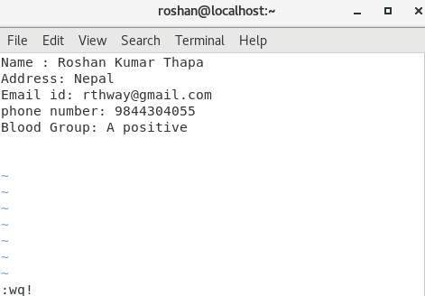

* Build one single expression to see the line with name and blood group in “myfile”

